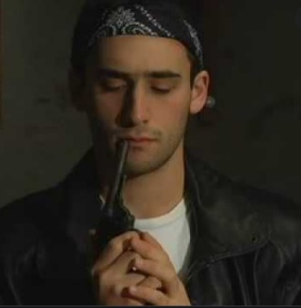**The Last Spin**

**By Evan Hunter**

First read this story: <https://www.classicshorts.com/stories/lastspin.html> and **answer the following questions:**

1. Why are the boys in the basement? What has happened? What do they need to do?
2. These boys belong to clubs. How do you recognize the club members and what kind of clubs are they?
3. What do think these phrases mean:

* Tigo would not turkey out of this particular rumble.
* Fair and square
* I’d like to work around pieces.
* We better lower the odds
* (Danny was) suprised that his thoughts had found a voice.
* You got heart, Danny.
* Listen, theydon’t like it, they can take a flying leap.

1. How come Danny and Tigo are not members of the same club?
2. Do they like their clubs? Give three examples of what they don’t like about their clubs
3. What is different between the relationship Danny and Tigo in the beginning of the story and at the end (or near-end) of the story?
4. Explain the title.
5. What do you think the theme* of this story is?

*\*Theme: main idea behind the story*